**ASSIGNMENT-1**

|  |  |
| --- | --- |
| Assignment Date | 25/09/2022 |
| Student Name | M.KISHORE KUMAR |
| Student Roll Number | 95071914051 |
| Maximum Marks | 1. Marks |

1. **Create registration page in html with username, email and phone number and by using POST method display it in next html page.**

**PROGRAM:**

**ass_1_1.py (Python File)**

from flask import Flask, render_template, redirect, request

app = Flask(__name__)

@app.route('/')

def home():

return redirect('/login')

@app.route('/login', methods=['POST', 'GET'])

def login():

if request.method == "POST":

username = request.form['name']

email = request.form['email']

phone = request.form['phone']

result = [username, email, phone]

return render_template('user_details.html', result=result)

return render_template("ass_1_1.html")

if __name__ == '__main__':

app.run(debug=True)

**HTML CODE:**

**ass_1_1.html(#1)**

<!doctype html>

**<html lang="en">**

**<head>**

<title>IBM Ass-1_1</title>

<meta charset="utf-8">

<meta name="viewport" content="width=device-width, initial-scale=1, shrink-to-fit=no">

<link rel="stylesheet" href="https://stackpath.bootstrapcdn.com/bootstrap/4.3.1/css/bootstrap.min.css"

integrity="sha384-ggOyR0iXCbMQv3Xipma34MD+dH/1fQ784/j6cY/iJTQUOhcWr7x9JvoRxT2MZw1T" crossorigin="anonymous">

**</head>**

**<body>**

<h1 align="center" class="text-primary" style="padding-top: 10px">Assignment-1_1</h1>

<div class="container">

<form action="/login" method="post" class="mb-4" style="text-align: center">

<div style="padding-left:90px;padding-right:80px;padding-top: 15px">

<div class="text-center bg-dark" style="padding: 20px">

<div class="form-group mb-3 text-success">

<label for="name">User Name</label>

<input type="text" name="name" id="name" class="form-control" placeholder="Enter your name: "

aria-describedby="helpId">

<small id="name_help" class="text-muted text-danger">Please type your name</small>

</div>

<div class="form-group mb-3 text-success">

<label for="email">Email</label>

<input type="email" name="email" id="email" class="form-control"

placeholder="Enter your email: " aria-describedby="helpId">

<small id="email_help" class="text-muted text-danger">Please type your E-mail</small>

</div>

<div class="form-group mb-3 text-success">

<label for="phone">Phone Number</label>

<input type="tel" name="phone" id="phone" class="form-control"

placeholder="Enter your Phone No. : " aria-describedby="helpId">

<small id="phone_help" class="text-muted text-danger">Please type your mobile</small>

</div>

</div>

</div>

<input class="text-primary" type="submit" name="submit" id="submit" class="form-control">

</form>

</div>

**</body>**

**</html>**

**user_details.html(#2)**

<!DOCTYPE html>

<html lang="en">

<head>

<meta charset="UTF-8">

<meta http-equiv="X-UA-Compatible" content="IE=edge">

<meta name="viewport" content="width=device-width, initial-scale=1.0">

<title>User Details</title>

</head>

<body>

<h1>User Details</h1>

<p>Username: {{result[0]}} </p><br>

<p>Email: {{result[1]}} </p><br>

<p>Phone: {{result[2]}}</p><br>

</body>

</html>

**OUTPUT:**

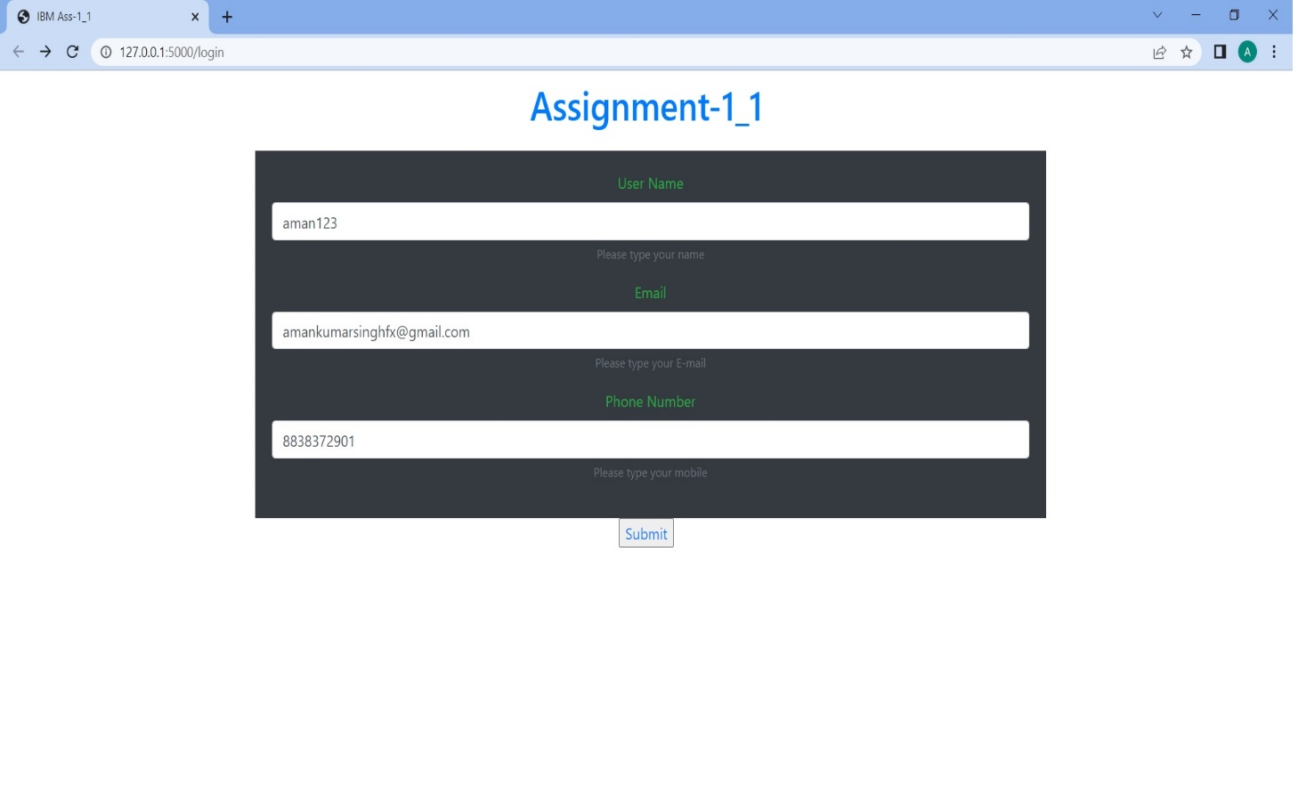

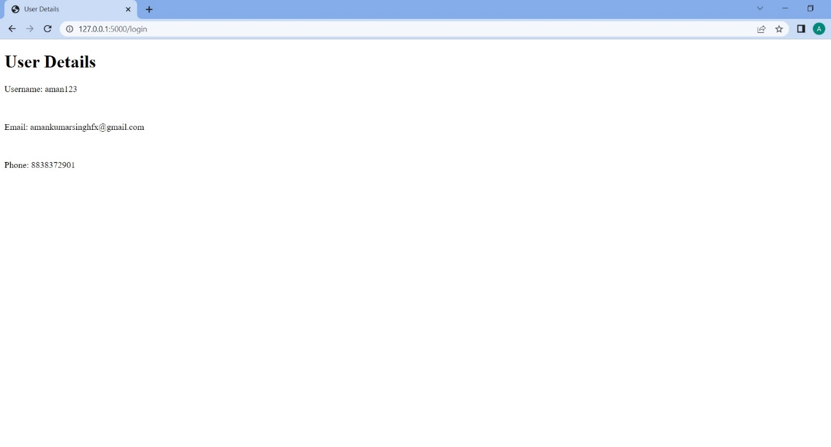

1. **Develop a flask program which should contain atleast 5 packages used from pypi.org**

**PROGRAM:**

**ass_1_2.py(#1)**

from camelcase import CamelCase

import numpy as np

from flask import Flask

from jinja2 import Template

import click

import requests

# __________________+++++++++++++++++++____________________________________++++++++++++++++++++++++++++++++

arr = np.array([4, 3, 8, 1, 2, 0])

print("This is to show NUMPY Package")

print(arr)

print(type(arr))

print("\n")

# __________________+++++++++++++++++++____________________________________++++++++++++++++++++++++++++++++

r = requests.get('https://api.spotify.com/')

r.status_code

print("This is to show REQUESTS Package")

print(r.headers)

print("\n")

# __________________+++++++++++++++++++____________________________________++++++++++++++++++++++++++++++++

template = """hostname {{ hostname }}"""

data = {"hostname": "core-sw-waw-01"}

j2_template = Template(template)

print("This is to show JINJA2 Package")

print(j2_template.render(data))

print("\n")

# __________________+++++++++++++++++++____________________________________++++++++++++++++++++++++++++++++

c = CamelCase()

txt = "lorem ipsum dolor sit amet"

print("This is to show CAMELCASE Package")

print(c.hump(txt))

print("\n")

# __________________+++++++++++++++++++____________________________________++++++++++++++++++++++++++++++++

print("This is to show CLICK Package")

@click.command()

@click.option("--count", default=1, help="Number of greetings.")

@click.option("--name", prompt="Your name", help="The person to greet.")

**def** ass_1_2(count, name):

"""Simple program that greets NAME for a total of COUNT times."""

for _ in range(count):

click.echo(f"Hello, {name}!")

**if __name__ == '_main_':**

**ass_1_2()**

**OUTPUT:**

